Case 1-Eur-France- Le Grand-Pressigny-Homo Erectus- Lower Acheulean 600 kya

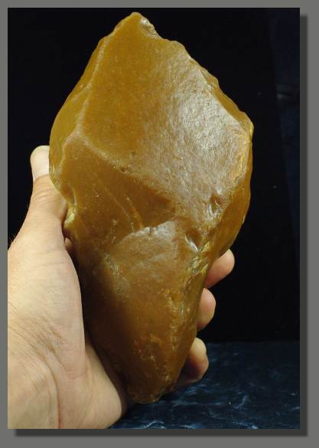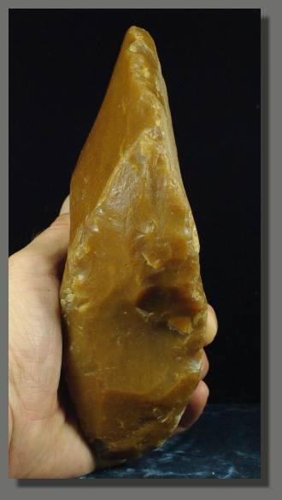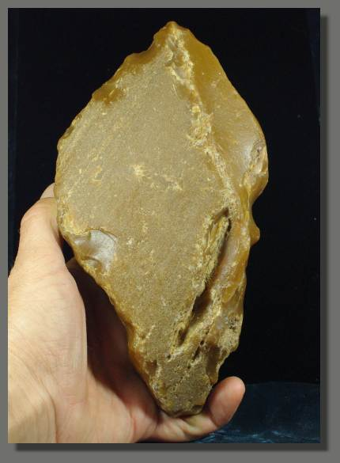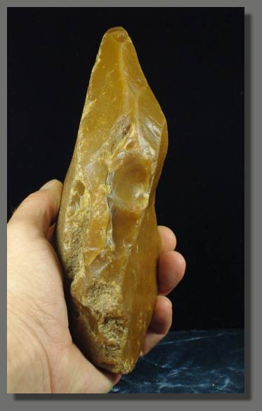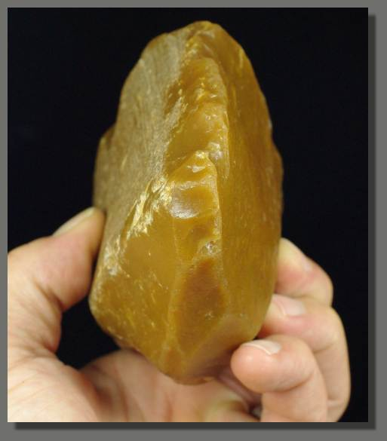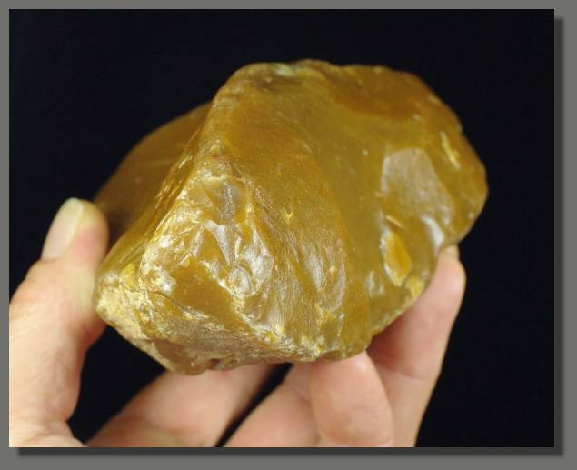

Eur-France- Le Grand-Pressigny-Homo Erectus- Lower Acheulean 600 kya

Case No.: 1

Accession Number:

Formal Label: Eur-France- Le Grand-Pressigny-Homo Erectus- Lower Acheulean 600 kya

**Display Description:**

This Proto-Bifacial handaxe from Le Grand-Pressigny, a commune in the Indre-et-Loire departement in central France, was made circa 650 – 500 kya (Lower Acheulean Culture, Lower Paleolithic period) by Homo Heidelbergensis (European Homo Erectus). It was discovered in the Creuse river's ancient riverbed, where it was polished by its sands and waters for millennia. This highly-prized caramel-colored flint is dated to the Turonian period, upper Cretaceous, ca. 93.5 to 89 million years ago. This flint was widely traded with examples having been found in the Pyrenees, Netherlands and Switzerland.

To make this tool, Homo Heidelbergensis used a large flat flake. The sides were cut to create the pointed tip; the base was cut to create a cutting-scraping edge as well as a point. On one side near the base a large flake was taken off to create a flat area ensuring a strong grip. The ventral face presents few large retouches and finer retouches on the edges. The dorsal face was left cortical, the edges of the point were finely retouched. Evidence of use is still visible along the edges and tip.

LC Classification:

Date or Time Horizon:

Geographical Area:

Map:

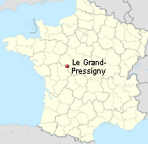

GPS Coordinates:

Cultural Affiliation:

Medium:

**Dimensions**: **Size: 7 1/2 inches X 4 inches or  19 cm X 10 cm.**  
**Weight:** Weight :**1150 gm.**

**Provenance**:

**Condition:**

**Discussion:**

**References:**